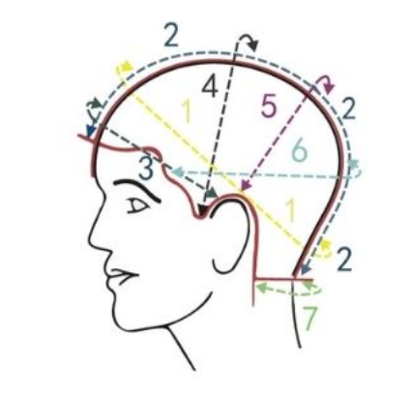
Full Wig Measurements
- Circumference: Inches
- Front to Back: Inches
- Ear to Ear over Forehead: Inches
- Temple to Temple: Inches
- Ear to Ear Over Top of Head: Inches
- Temple to Temple Over Back of Head: Inches
- Width of Neck from side to side: Inches
= Edge of Wig

Regular Wig Sizes
Part | Regular Size 1 | Regular Size 2 | Regular Size 3 | Regular Size 4 | Regular Size 5 | Regular Size 6
1 | 19" | 20" | 21" | 22" | 23" | 24"
2 | 12 1/2" | 12 3/4" | 13 1/4" | 13 1/2" | 14" | 14 1/2"
3 | 9 3/4"－10 1/4" | 10 1/4"－11" | 10 3/4"－11 3/4" | 11 1/4"－12 1/4" | 11 1/2"－12 1/2" | 11 3/4"－12 3/4"
4 | 11"－12" | 11 1/2"－12 1/2" | 12"－13" | 12 1/4"－13 1/4" | 12 1/2"－13 1/2" | 12 3/4"－14"
5 | 10 1/4"－11 1/4" | 10 1/2"－11 3/4" | 11"－12" | 11 1/4"－12 1/4" | 11 1/2"－12 1/2" | 11 3/4"－12 3/4"
6 | 12 1/4"－13 1/4" | 12 1/4"－13 1/4" | 12 1/2"－13 1/2" | 13"－14" | 13"－14 1/2" | 13 1/2"－15"
7 | 3 1/2" | 4" | 4"－4 1/2" | 4 1/2" | 5" | 5 1/2"

